Yes! I would like to be a member of the Shining light Foundation.  _____________________________________________  Name  _____________________________________________  Company Name  _____________________________________________  Address  _____________________________________________  City State Zip Code  _____________________________________________  Phone Fax  _____________________________________________  Email Address  ( ) I wish to remain anonymous  Levels of Contributions  ____ Musicians’ Memorial- Any musical instrument  ___ Twinkle $ .50 - $ 49.00  ___ Moonbeam $ 50.00 - $ 99.00  ___ Sunshine $ 100.00 - $ 249.00  ___ Star $ 250.00 - $ 499.00  ___ Shooting Star $ 500.00 - $ 999.00  ___ Constellation $1,000.00- $4,999.00  ___ Galaxy $5,000.00 and above  _____________________________________________  Please make checks payable to:  “Shining Light Foundation”  Shining Light Foundation is a non-profit 501(c)((3) organization & your Contribution may be tax deductible | Levels of Contributions  Musicians’ Memorial  Any musical instrument  Galaxy  $5000.00 and above  Constellation  $1,000.00 – $4,999.00  Shooting Star  $500.00 –$999.00  Star  $250.00 –$499.00  Sunshine  $100.00 – $249.00  Moonbeam  $50.00 –$99.00  Twinkle  $ .50 - $49.00 | 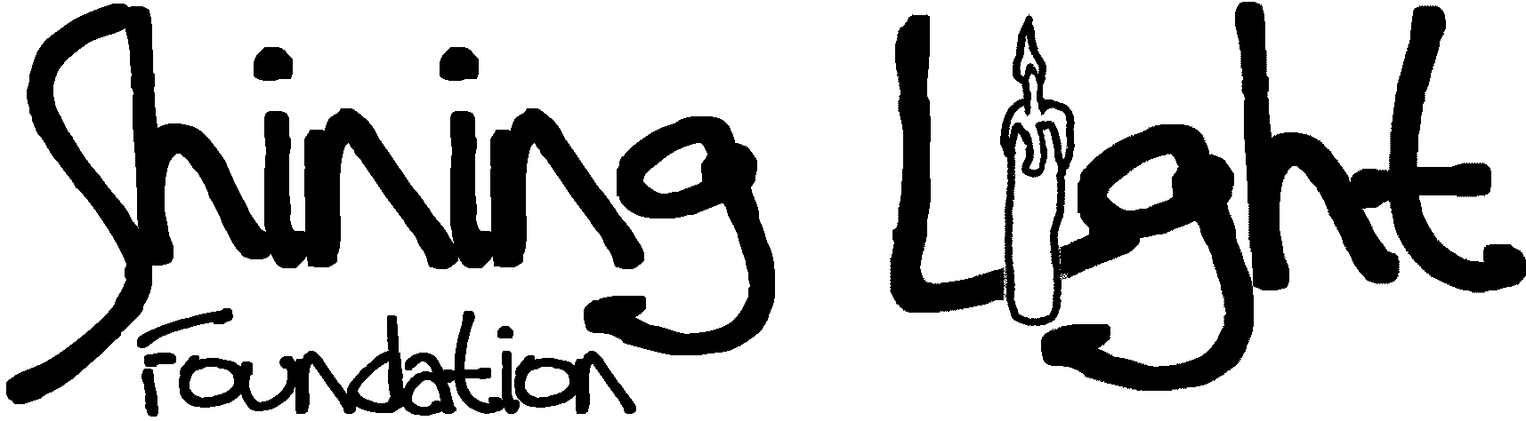  Musicians’ Memorial  Instrument Drive    www.shininglightfoundation.org  Contact:Cynthia@xtrahandz.com
  The Shining Light Foundation welcomes individual and corporate contributions. Any donation will help to provide academic enrichment opportunities for underserved students from low-income families in grades K-8 in Lafayette's public schools. Musical instruments may be awarded to public schools throughout Acadiana..
  The Shining Light Foundation provides assistance to underserved children from low-income families for academic enrichment. The Foundation is a non-profit, 501(c)(3) organization.
  Mission of Musicians’ Memorial Instrument Drive:
  To provide musical instruments for underserved children from low-income families for the purpose
  of academic enrichment through participation in their school bands..
Who Is Eligible to Submit Applications:  Any teacher, counselor, or band director in K-8 public schools in Lafayette Parish is eligible to apply. Applications may also be made through the Acadiana Center for the Arts’, “Play It Again Sam” program.  Qualifications for Instrument Awards:  Any individual student from a low-income family, who is enrolled in K-8 public school in Lafayette Parish, or any band director of a public school in Acadiana.  Instrument Awards:  Subject to Awards Committee Review  And availability of musical instruments.  ________________________________  Additional information and application forms are available from:  Shining Light Foundation  P.O. Box 60602  Lafayette, LA 70596  Visit our web site at www.shininglightfoundation.org or  Contact: Cynthia@xtrahandz.com  . | Officers:  Carolyn French, Ph.D.  President  Cynthia Dauphin  Vice President  Bruce Snow  Treasurer  Mildred Baker  Secretary  Perry Scotola  Parliamentarian  Lana Swanwick  Hospitality  Board of Directors:  John Broussard  Tanya Comier  Kerry Douglas  Julie Eaton  Cheryl Evans  Mike Huber  Dr. Don Innis  Michelle Izzo-Voss  Hayley LeJeune  Barbara Moore  Debbey Ryan  Sandra Wilcox  Advisors:  Heather Fuller  Dr. Ron Hardey  Ted Hoyt  Liz Leda  Tony Moor  Maria Placer | 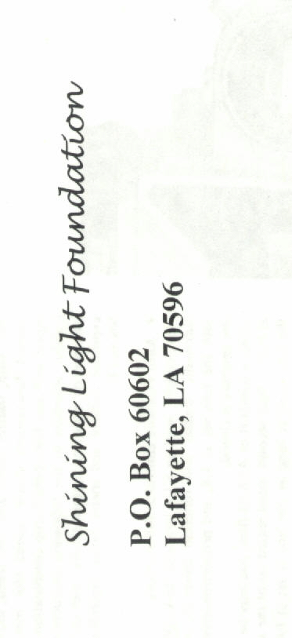
  Musical instruments will be provided for bands throughout Lafayette Parish public schools and Acadiana.

